8.8 Practice Name: _____________________

For each function below, list all transformations and the domain and range.

1. $f(x)=\frac{5}{x+2}-1$ 2. $f(x)=-\frac{2}{x+3}$

3. $f(x)=\frac{1}{x-4}-3$ 4. $f(x)=-\frac{4}{x+1}+2$

Write the equation for the following.

5. Write the equation for a rational function that has been moved right 1, up 6, stretched vertically by a factor of 4 and is reflected over the x-axis.

6. Write the equation for a rational function that has been moved left 4, up 6, and is reflected over the x-axis.

7. Write the equation for a rational function that has been moved right 9, down 2, stretched vertically by a factor of 3 and is reflected over the x-axis.

Describe the asymptotic behavior of each graph.
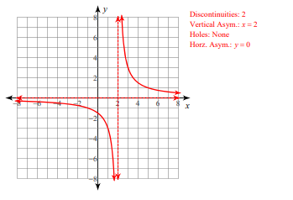
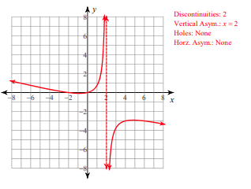
8. 9.

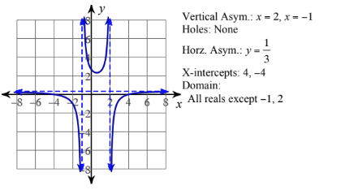
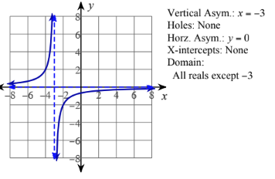
10. 11.

